**INSTITUTE OF ENGINEERING**

ADVANCED COLLEGE OF ENGINEERING AND MANAGEMENT

Kupondole, Lalitpur

**(AFFILIATED TO TRIBHUVAN UNIVERSITY)**



Lab no:1

Subject: Computer Network

**Submitted By: Submitted To:**

Department of Computer

and

Electronics Engineering

Name: Sameep Dhakal

Roll no: ACE074BCT063

Date: 09/07/2021

**Title: Network wiring and LAN setup**

**Objective:**

To learn about the setup and connection between different devices and routers

**Introduction:**

Network wiring is the process of interconnecting various components of a network. Depending on the type of device being connected and the type of connection being used various methods have to be followed in order to ensure proper communication between the devices.

LAN (Local Area Network) is a computer network that interconnects computers within a limited area. The setup of a LAN depends on various factors like type of connection, distance between communicating components and available resources among others. So, it is important to learn about the setup of a LAN in various types of situations.

**Design:**

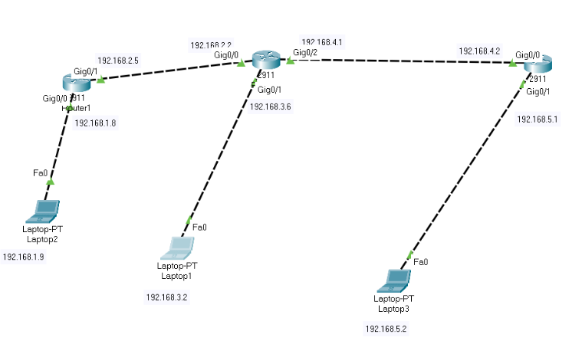

Three different laptops are connected using three different routers. The 2911 routers are used for the connection.

**Procedure:**

1. First the required tools were selected.
2. The required ports of the routers were turned on.
3. Then the IP and subnet mask for each Laptop and router ports was set
   1. For laptops this was gone by going to the desktop and ip configurations

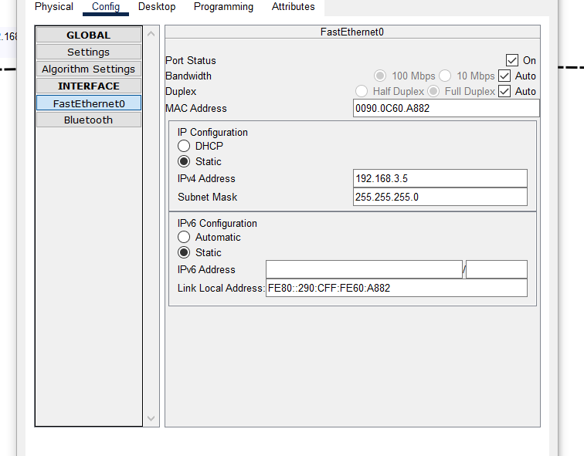

* 1. 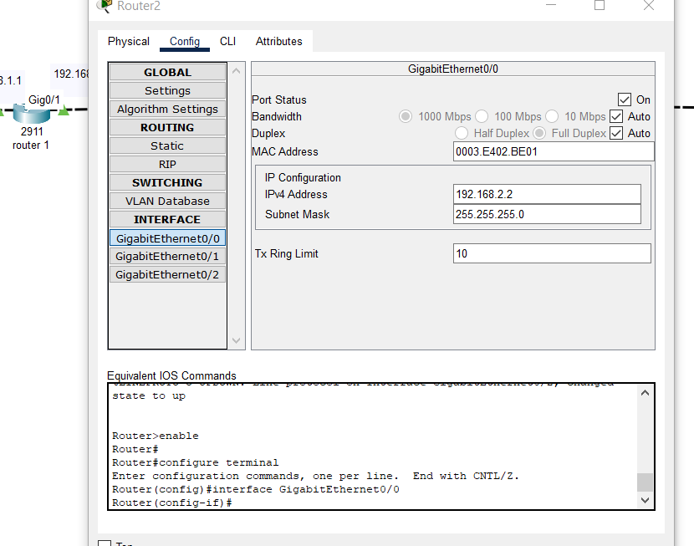For routers this was done by going to the configuration and selecting the required port

1. Required connections were made between the routers and laptops.
2. Then the routing information was given to each router through the routing option in the config tab.

**Output**

Ping form laptop 1 to laptop 2:

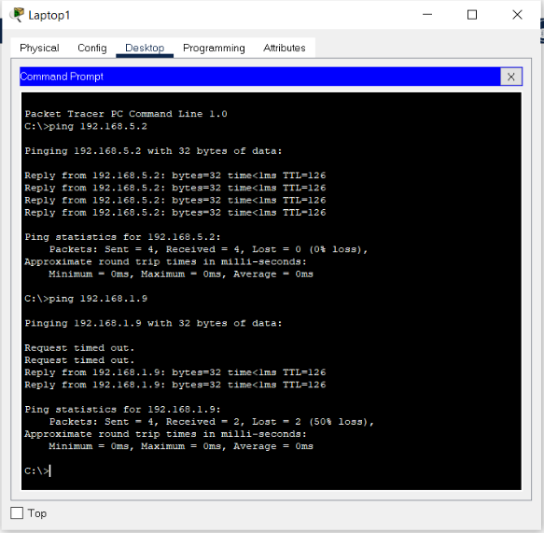

Ping form laptop 1 to laptop 3:

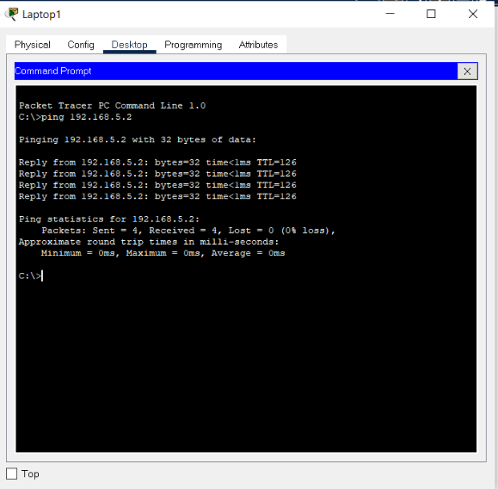

Ping form laptop 2 to laptop 1:

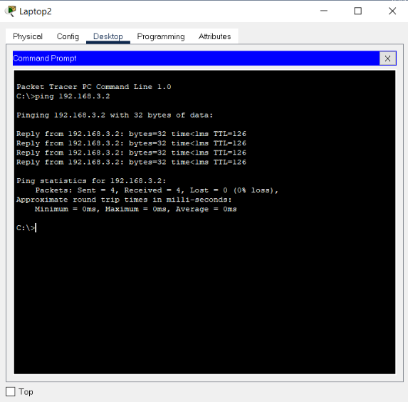

Ping form laptop 3 to laptop 1:

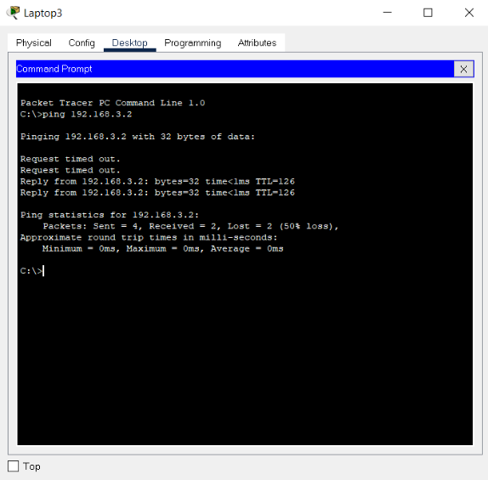

**Result and Conclusion**

In this lab we created a simple LAN consisting of 3 laptops and 3 routers. Hence we learned how to establish a simple LAN connection through ethernet cables.